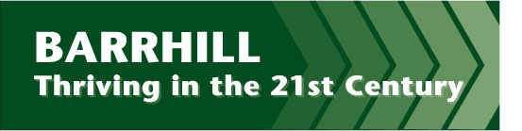
Barrhill Community Council

Small Grants Application Form (up to £500)

Contact Details:

Name of group or individual applying

Main contact

Address
Postcode

E-mail Telephone (main)

About you and / or your organisation:

Where does your group operate?

Are you a constituted group? Y / N

If you are not a constituted group please explain who is involved in the group and what has brought you together?

If you are not a constituted group, please indicate the sponsoring organisation that will receive the grant on your behalf and account for it in due course.

Name of organisation:

Details of grant request:
Please provide details of your project – what activities will you carry out, who are the beneficiaries?

How much are you requesting? (Up to £500)

What will the small grant be used to pay for? (Please provide a cost breakdown)

Declaration: I certify that the information contained in this application is correct, and that I am authorised to make the application on behalf of the above group / individual.

Name (please print):

Signature: Date:

Declaration from sponsoring organisation where application is from a non-constituted group: I certify that we are supporting this group to undertake this project by administering the grant on their behalf.

Name (please print):

Signature: Date:

Please send your completed applications to the appropriate contact person for your Community Council.

If you’re not sure who that is, please contact the Carrick Futures secretariat on 01557 814927 or office@foundationscotland.org.uk

